**Interactive Data Visualization**

Python Data Analysis Project

**Introduction :**

GDP per capita is a crucial economic indicator that measures the economic output per person within a country. It is calculated by dividing a country's Gross Domestic Product (GDP) by its population, providing a per-person measure of the standard of living. Higher GDP per capita generally indicates a wealthier, more developed country with a higher standard of living, while lower GDP per capita may suggest underdevelopment or economic challenges.

This analysis aims to explore the GDP per Capita trend over time, comparing it across multiple countries for a selected year. By examining the GDP per capita data, we gain valuable insights into how countries are performing economically, allowing us to understand their relative wealth and development.

**DataSet Overview : -**

The dataset provides economic data, specifically GDP per Capita for various countries over time.

* Country :- This column contains the names of countries for which GDP per capita data is provided. It serves as the primary identifier for each country's data.
* Code :- This column contains a short code or abbreviation for each country. It is typically used for referencing countries in a compact form (e.g., "USA" for the United States, "GBR" for the United Kingdom).
* Year :- This column represents the year for which the GDP per capita is recorded. The dataset includes historical data, spanning across multiple years for each country.
* GDP_per_capita :- This column contains the Gross Domestic Product per Capita for each country and year, which is calculated as the total GDP of a country divided by its population. The value is usually expressed in constant US dollars to account for inflation across different years.

**Importance of Analysis :**

GDP per capita analysis is crucial for assessing a country's economic development and understanding global wealth distribution. It serves as an indicator of a nation's standard of living, with higher GDP per capita generally reflecting better living conditions, access to healthcare, and overall economic well-being. By comparing GDP per capita across countries, we can identify disparities in economic development and wealth distribution, helping policymakers and international organizations target aid, trade policies, and development programs effectively. It also allows for tracking economic growth, identifying periods of recession or expansion, and evaluating the impact of economic policies.

Furthermore, GDP per capita analysis plays a vital role in global economic planning and forecasting. It helps businesses make informed investment decisions, aids governments in designing long-term development strategies, and supports international organizations in allocating resources effectively. By examining trends over time, this analysis also provides insights into a country's potential for future growth, poverty alleviation, and social policy formulation, ensuring that economic growth benefits the population and reduces inequalities.

1. **Import and Load Dataset :-**

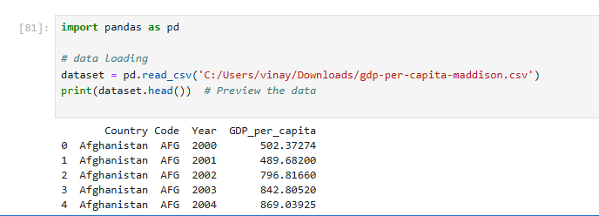

1. **Preview the Data :-**

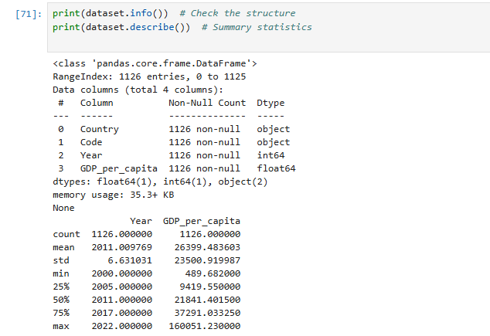

1. **Remove missing value :-**



1. **Visualization :**

* GDP per Capita Trend Visualization

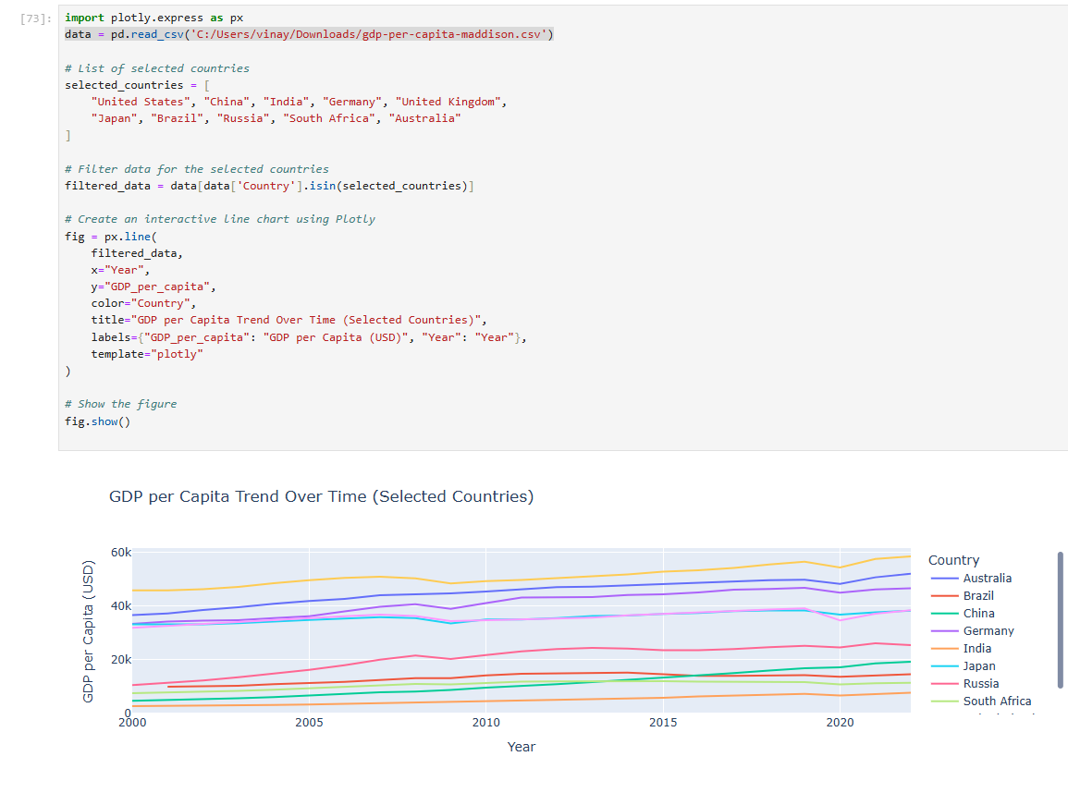

* 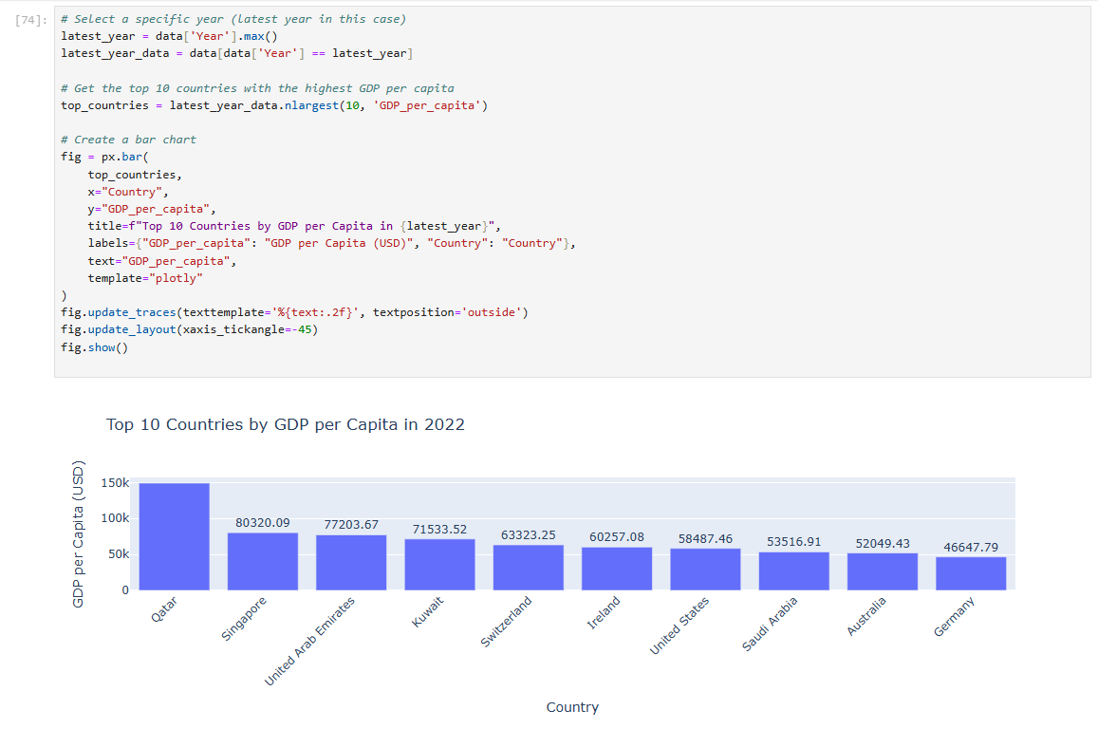Bar Chart : Top 10 countries
* 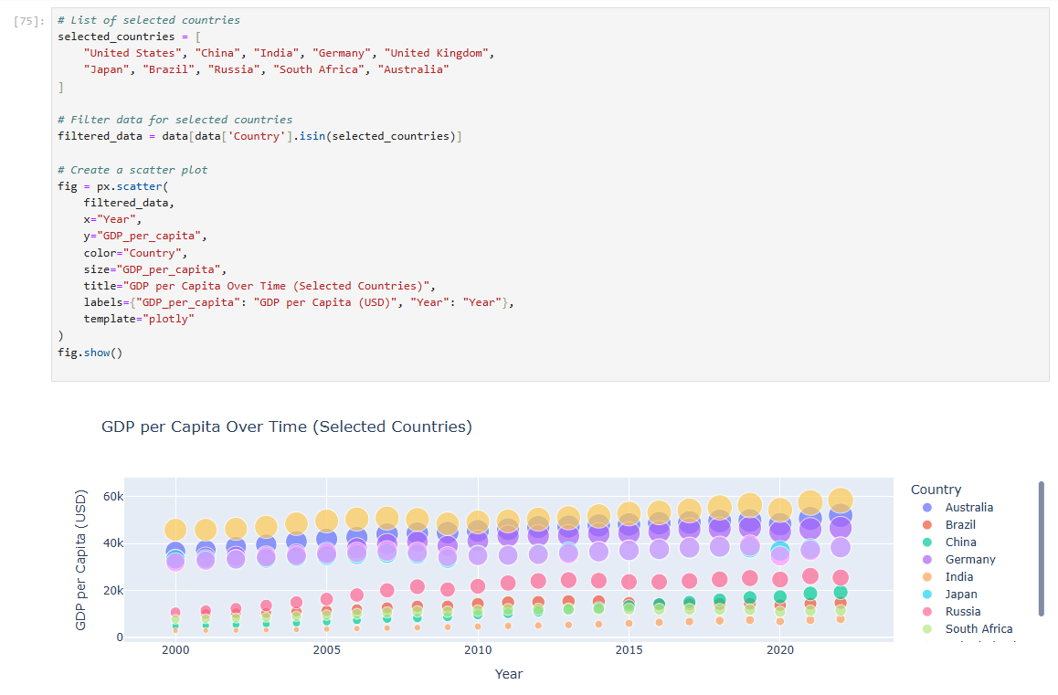Scatter Plot :
* Area Chart :

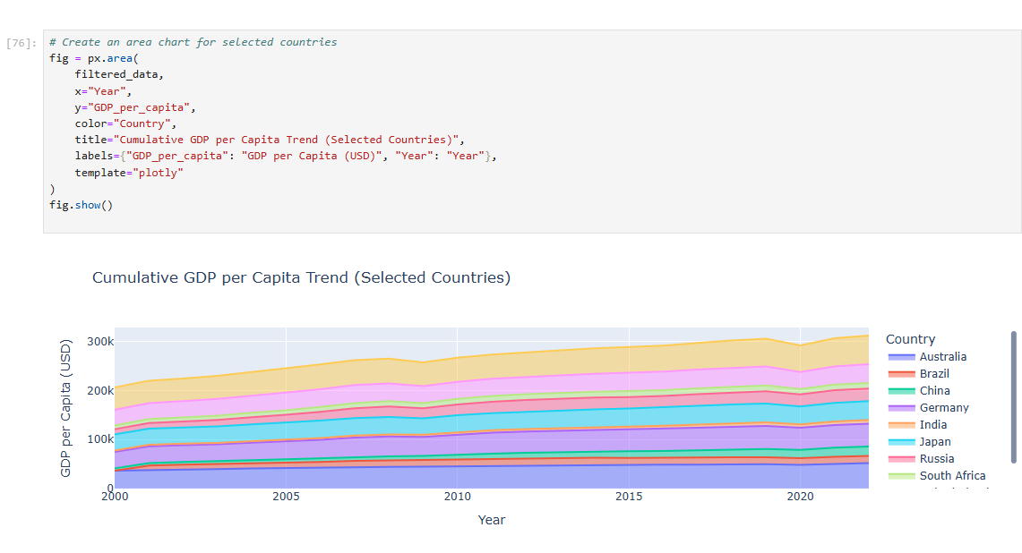

* Facet line Chart :

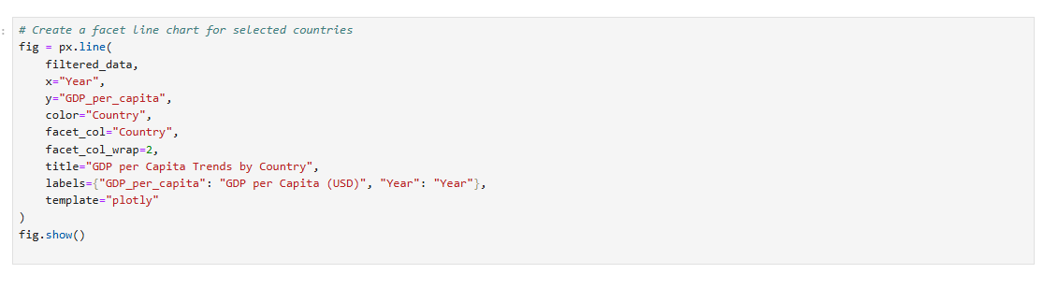

1. 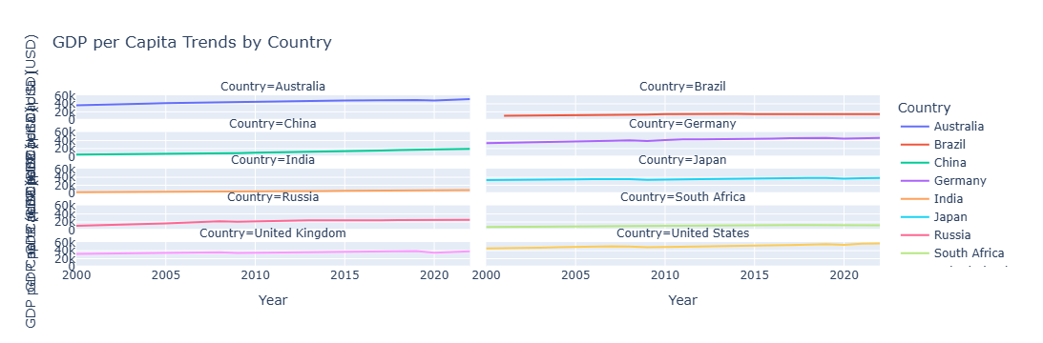**Comparisons :-**

* Bar Chart : Comparing GDP per capita for countries for a Given year…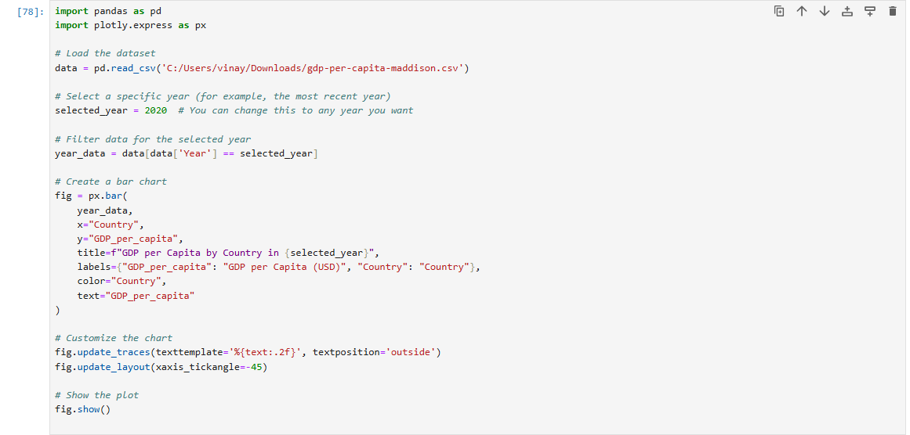
* 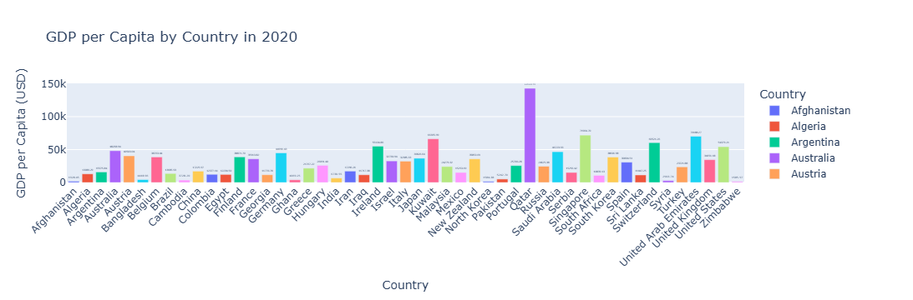Box Plot : Comparing GDP per capita Distribution across Countries…

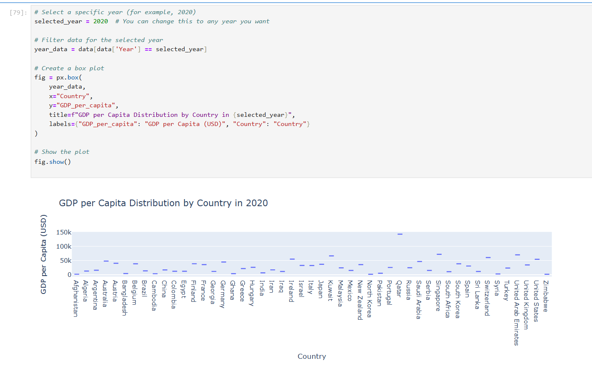

1. **Insights :**

The GDP per capita analysis highlights significant disparities in wealth and living standards across countries. High-income nations such as the United States and Switzerland display much higher GDP per capita, reflecting their developed economies, while countries in regions like sub-Saharan Africa and parts of South Asia show much lower figures. These differences often correlate with varying levels of infrastructure, healthcare, and education. This analysis serves as a powerful reminder of the global inequalities that persist and the need for targeted economic policies to address these gaps.

Over time, the analysis also reveals the economic growth trajectories of various nations. Countries like China and India, for example, have shown remarkable progress in GDP per capita due to rapid industrialization, technological advancements, and improved living conditions. This growth offers hope that developing nations can break free from poverty and raise their citizens’ standards of living. Conversely, countries facing political instability or economic crises may struggle with stagnant or declining GDP per capita, underscoring the importance of stable governance and sound economic policies in fostering sustainable growth.

Finally, this analysis emphasizes the relationship between economic growth and poverty alleviation. As nations experience growth in GDP per capita, they often see reductions in poverty and improvements in quality of life. However, the analysis also shows that not all economic growth leads to equitable prosperity. Some countries with high GDP per capita still face significant social challenges, such as income inequality. Therefore, while economic growth is essential, it must be accompanied by social policies that ensure the benefits are shared more broadly to improve the overall well-being of citizens.

**Summary**

The GDP per capita analysis reveals the stark economic inequalities that exist between countries, with wealthier nations like the U.S. and Switzerland showing significantly higher figures, while developing regions such as sub-Saharan Africa face much lower levels of prosperity. The analysis also highlights the impressive growth in countries like China and India, where industrialization and technological advances have lifted millions out of poverty. However, it also underscores that growth alone isn’t enough; despite rising GDP per capita, many countries still struggle with issues like income inequality. This shows that while economic growth is crucial, it must be accompanied by policies that ensure the benefits reach all citizens, improving overall living standards and reducing disparities.

**Vinay Upadhyay** | LinkedIn